Name : Gowtham S
EXPT NO:4 | TRANSFORM DATA TO SUIT BI REPORTING REQUIREMENTS AND  DESIGN A DASHBOARD WITH KEY PERFORMANCE INDICATORS (KPIs ) USING TABLEAU AND POWERBI
DATE: 24.07.2026
Roll No : 24BAD028

PRE-LAB QUESTIONS

- What is the role of data transformation in BI reporting?
Data transformation is the process of converting raw data into a clean and structured format. It improves data quality, ensures consistency, removes errors, and prepares the data for accurate analysis and reporting in BI tools like Tableau and Power BI.

- What are the common data cleaning techniques in Tableau and Power BI?
Common data cleaning techniques include:
- Removing duplicate records.
- Handling missing (null) values.
- Correcting inconsistent data formats.
- Renaming columns for clarity.
- Filtering unnecessary data.
- Changing data types (e.g., text to date or number).

- How do Tableau and Power BI handle data aggregation?
Tableau and Power BI automatically aggregate numerical data using functions such as SUM, AVERAGE, COUNT, MIN, and MAX. Users can also customize the aggregation level to analyze data by categories, dates, or regions.

- What are KPIs, and why are they important in a dashboard?
Key Performance Indicators (KPIs) are measurable values that track the performance of an organization or process. They help users quickly monitor progress, identify trends, measure success, and support better decision-making through dashboards.

- What are the different types of charts available in Tableau and Power BI for visualization?
Both Tableau and Power BI support various visualization charts, including:
- Bar Chart
- Line Chart
- Pie/Donut Chart
- Scatter Plot
- Tree Map
- Heat Map
- Map (Geographical Chart)
- Area Chart
- Table/Matrix
- KPI Cards
- Combo Chart (Bar + Line)

IN-LAB EXERCISE:
OBJECTIVE:
To transform COVID-19 data into a structured format suitable for Business Intelligence (BI) reporting and design interactive dashboards with Key Performance Indicators (KPIs) using Tableau and Power BI.
PROCEDURE:
- Data Collection:
  - Import the COVID-19 dataset from inbuilt sources like Our World in Data or CSV files containing country-level COVID statistics (e.g., new cases, deaths, vaccinations).
  - Datasets may include fields such as date, location, new_cases, total_cases, new_deaths, total_deaths, people_vaccinated, etc.
- Data Cleaning and Transformation:
  - Convert columns like date to proper date formats.
  - Handle missing or null values in new_cases, total_cases, etc.
  - Create calculated fields (e.g., daily case growth rate, case fatality rate, vaccination percentage).
- Data Aggregation:
  - Aggregate data by continent, country, or month.
  - Use measures like SUM(new_cases), AVG(positivity_rate), MAX(total_deaths).
- Designing KPIs:
  - Identify KPIs such as:
    - Total Confirmed Cases o Total Deaths o Case Fatality Rate o Vaccination Coverage (%)
    - Daily Case Growth Rate
  - Use DAX (Power BI) or Calculated Fields (Tableau) to compute and visualize these KPIs.
- Dashboard Development:
  - Build visualizations such as:
    - Line charts for daily new cases and deaths o Bar charts for country-wise vaccination progress o Maps to show regional case distribution
    - KPI cards for high-level insights
  - Use filters (e.g., by continent, country) and slicers (e.g., by date range) for interactivity.
- Publishing and Sharing:
  - Publish the dashboard using Tableau Public/Server or Power BI Service.
  - Share the dashboards with stakeholders through public or organizational portals.

Screenshots of tableau :
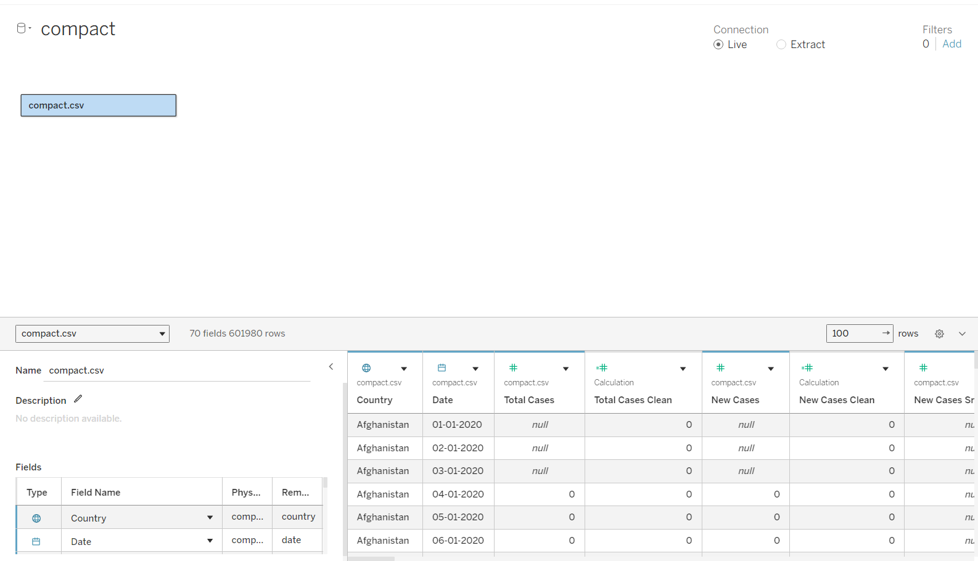
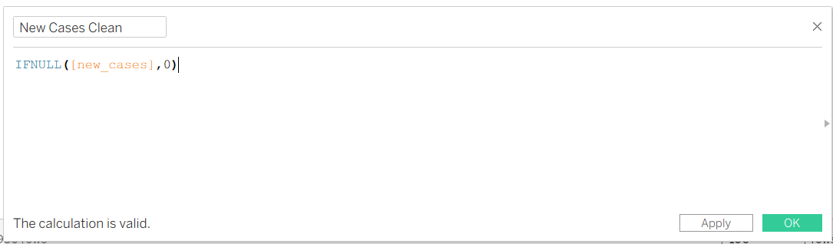
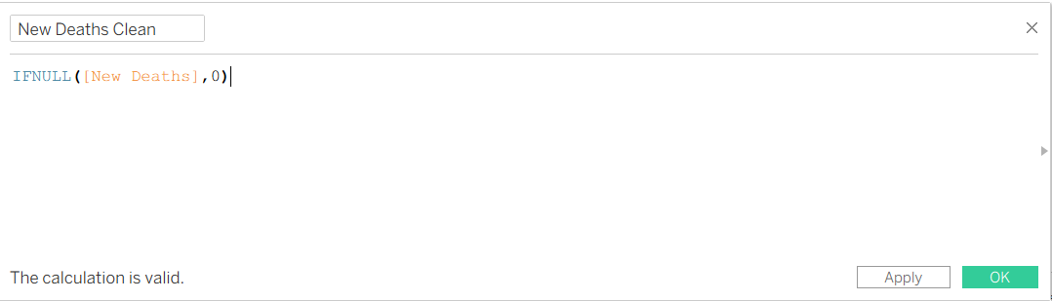
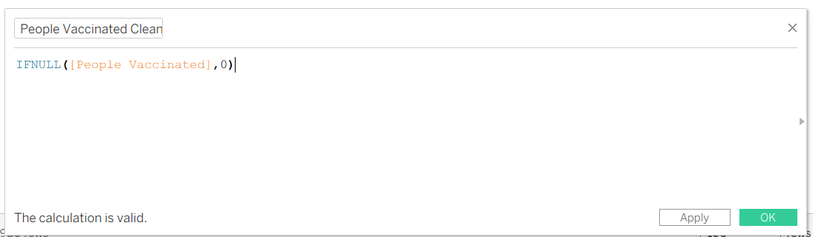
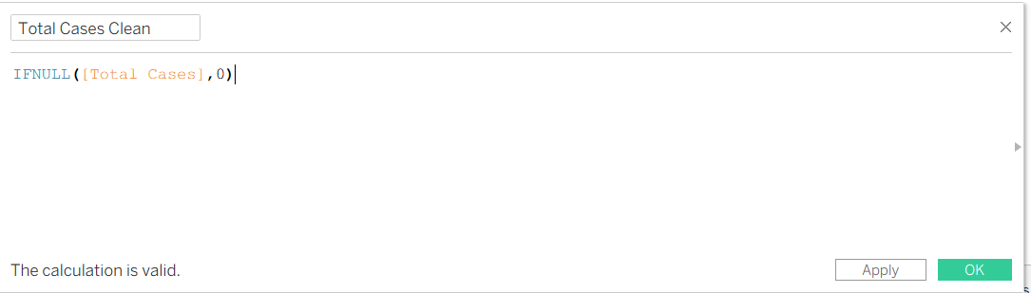
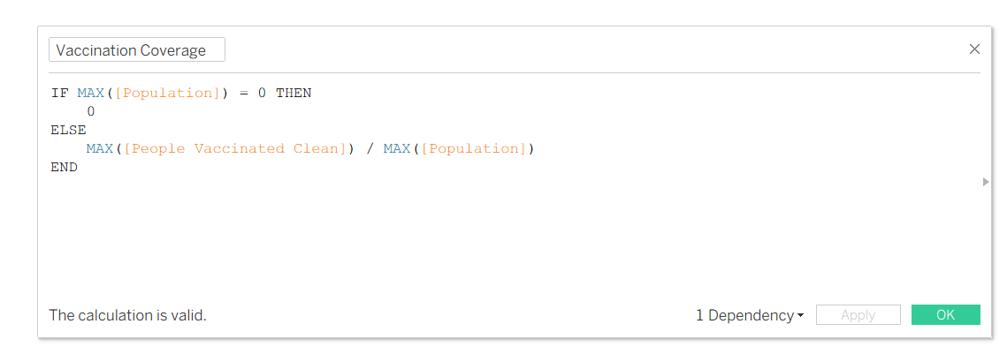
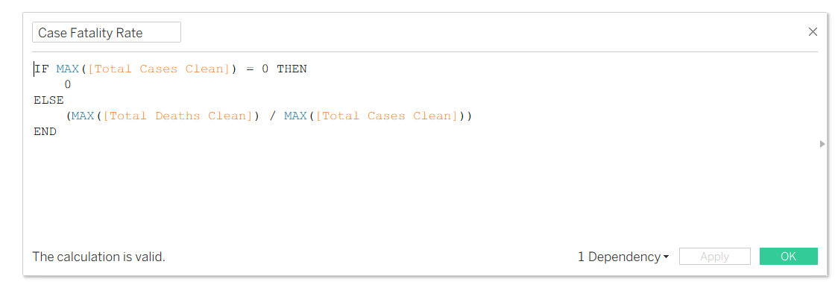
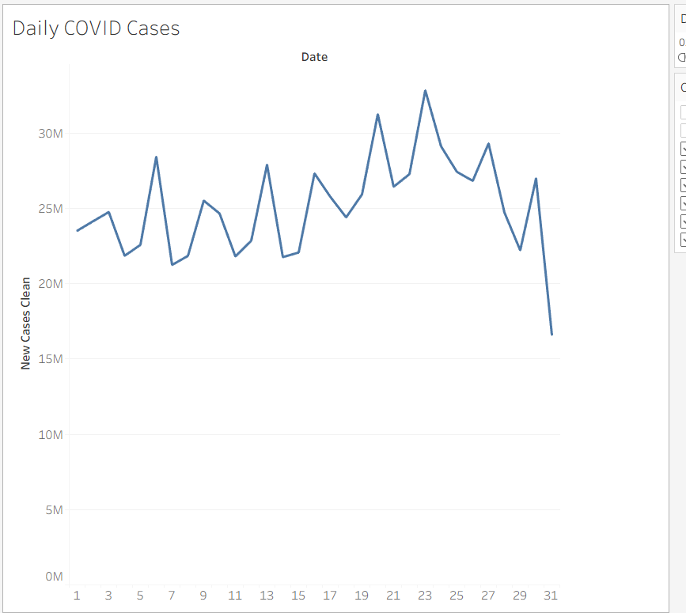
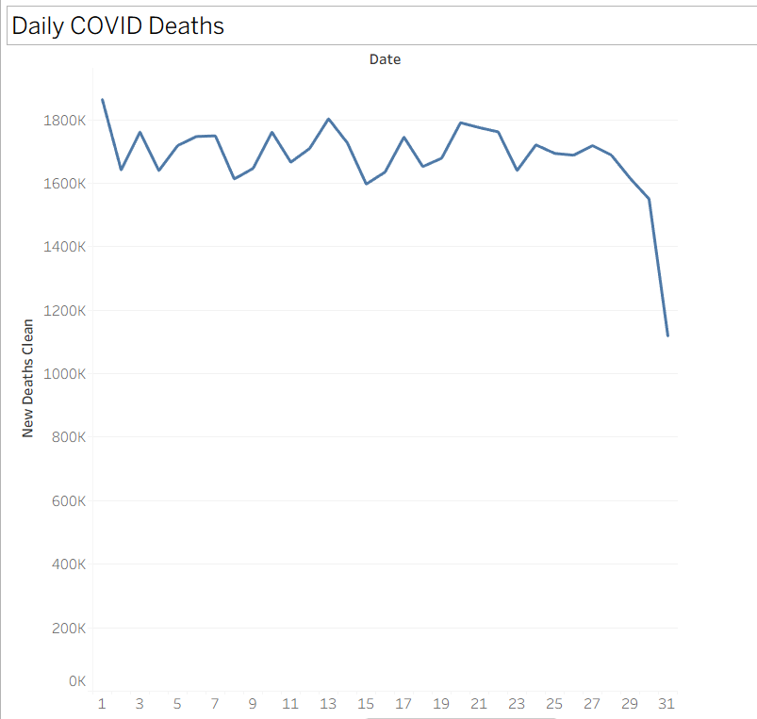
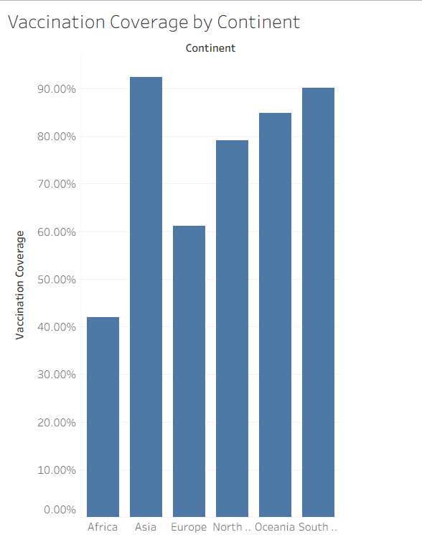
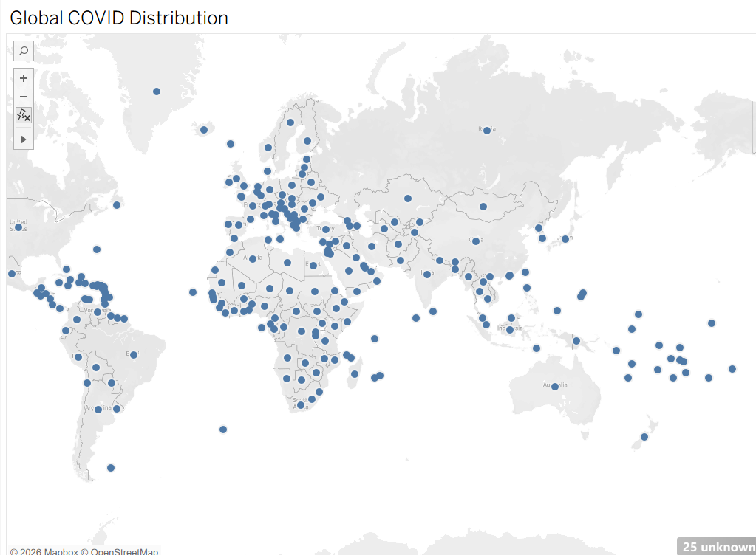
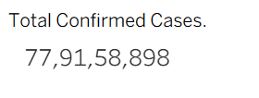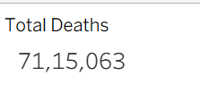
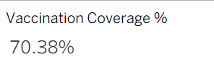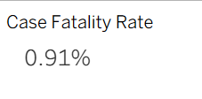

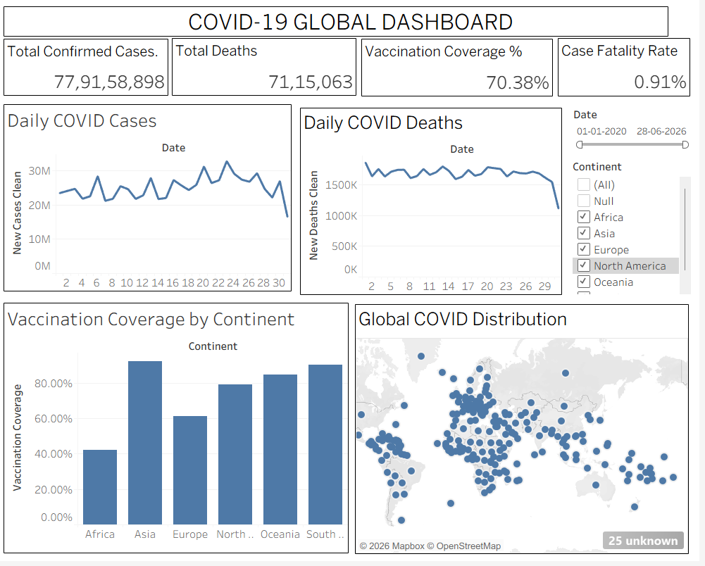

Screenshots of PowerBI :
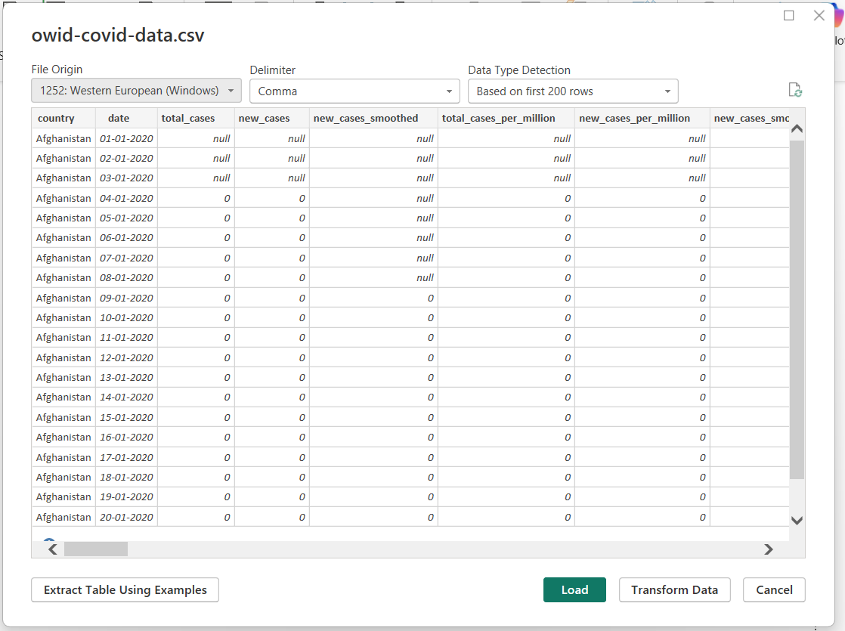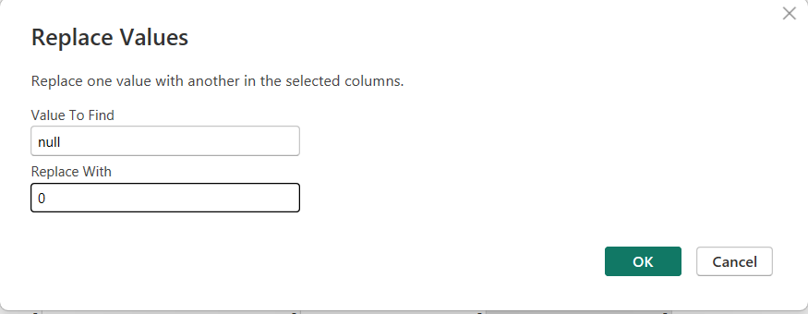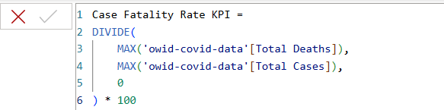
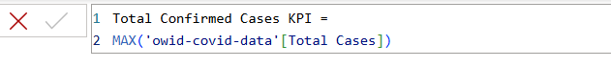
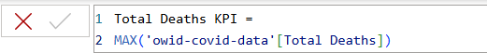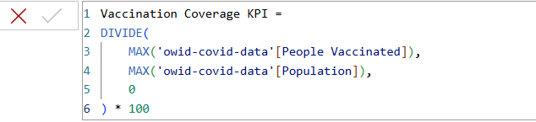
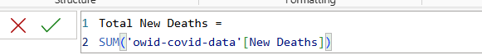
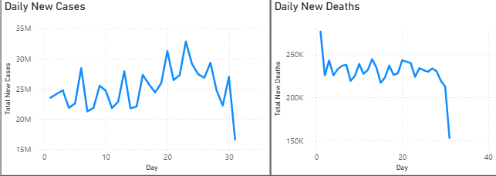
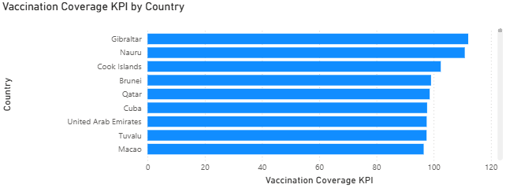
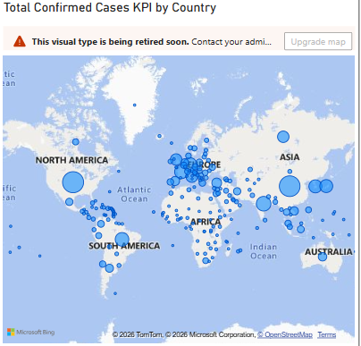
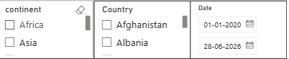
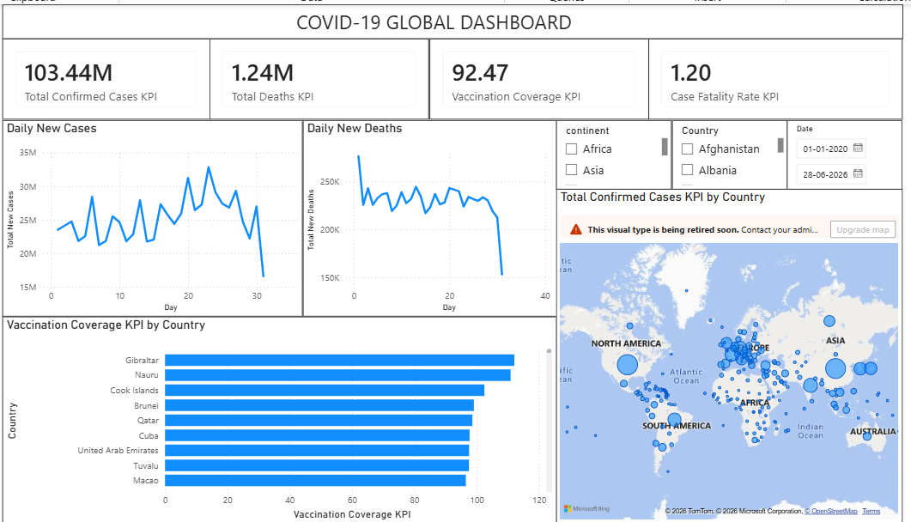

Experiment Dataset: COVID-19 Global Dataset
Fields Used:
  - Date – Date of the report
  - Location – Country or region
  - New Cases – Daily reported cases
  - New Deaths – Daily reported deaths
  - People Vaccinated – Cumulative vaccinated count
  - Total Cases – Cumulative confirmed cases
  - Total Deaths – Cumulative deaths
  - Population – Total population of the country

POST-LAB QUESTIONS
  - How did data transformation improve the quality of insights in your COVID-19 dashboard?
Data transformation improved the accuracy and readability of the dashboard by converting the date column into the correct format, handling missing values, and filtering out non-country records. It also helped create calculated fields such as Case Fatality Rate and Vaccination Coverage, making the analysis more meaningful and reliable.

  - What challenges did you encounter during the data cleaning process, and how did you resolve them?
The main challenges were missing values, incorrect data types, and the presence of aggregate records such as "World" and income groups. These were resolved by replacing or handling null values, converting the date field to the proper format, filtering out non-country records, and verifying that all numerical columns had the correct data type.

  - Which KPI provided the most valuable insight, and why?
The Vaccination Coverage (%) KPI provided the most valuable insight because it showed the percentage of the population that had received vaccinations. This made it easy to compare vaccination progress across countries and understand how effectively vaccination campaigns were implemented.

  - How does interactivity in dashboards improve user experience?

Interactive dashboards allow users to filter data by country, continent, and date, making it easier to explore specific information without creating multiple reports. Features such as slicers, filters, and maps help users quickly identify trends and compare different regions, improving decision-making.

  - What steps would you take to further enhance the dashboard’s effectiveness?
To improve the dashboard further, I would add more KPIs such as recovery rate and testing rate, include forecasting for future trends, optimize the visual layout for better readability, use drill-through pages for detailed country-level analysis, and schedule automatic data refresh so the dashboard always displays the latest information.

RESULT:

The COVID-19 dataset was successfully cleaned, aggregated, and transformed for visual analysis using Tableau and Power BI. Missing values, data type mismatches, and inconsistencies were addressed. KPIs such as vaccination rate and daily case growth offered valuable insights into the pandemic trends across countries and timeframes. The resulting interactive dashboards allowed for effective public health monitoring and communication.

ASSESSMENT

Description |  | Max Marks | Marks Awarded
Pre Lab Exercise |  | 5
In Lab Exercise |  | 10
Post Lab Exercise |  | 5
Viva |  | 10
 | Total | 30
 | Faculty Signature

